LAB 10
Views

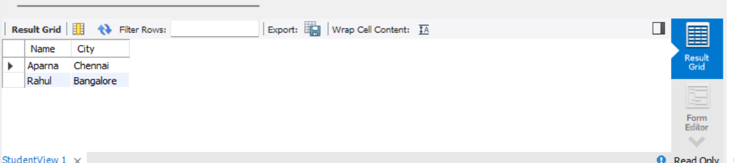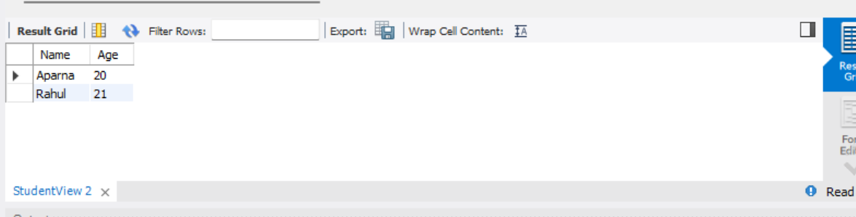
1. Create View: Creates a view named StudentView that displays the Name and City columns from the Students table.
2. Retrieve Data from View: Displays the Name and City of all students from the StudentView.
3. Update View: Modifies the StudentView to display the Name and Age columns instead of Name and City.
4. Retrieve Updated View: Displays the Name and Age of all students from the updated view.
5. Drop View: Deletes the StudentView permanently from the database. The original Students table remains unchanged.

